International Chamber of Shipping  38 St Mary Axe London EC3A 8BH  Tel: +44 (0)207 090 1460  Fax: +44 (0)207 090 1484  www.ics-shipping.org www.shipping-facts.com  This Circular and its attachments (if any) are confidential to the intended recipient and may be privileged. If you are not the intended recipient you should contact ICS and must not make any use of it. | 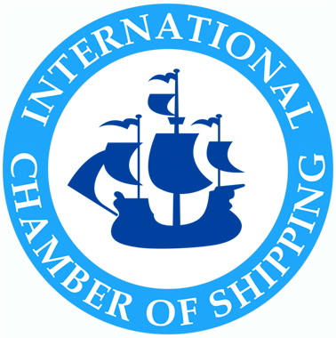
ICS/14/1 23 December 2011

TO: MARITIME LAW COMMITTEE MLC(11)40

Copy to: MARINE COMMITTEE
CONSTRUCTION & EQUIPMENT SUB-COMMITTEE
ENVIRONMENT SUB-COMMITTEE
ALL FULL AND ASSOCIATE MEMBERS (for information)

CHINA: REGULATIONS ON THE PREVENTION AND CONTROL OF MARINE POLLUTION FROM SHIPS: IG CLUBS’ FAQs AND FURTHER GUIDANCE ON CONTRACTING WITH CHINA MSA APPROVED SPILL RESPONSE ORGANISATIONS

Action Required: To note the attached International Group P&I Club Circular and FAQs providing further guidance from the International Group of P&I Clubs regarding the implementation of the Regulations On the Prevention and Control of Marine Pollution from Ships (the “Regulations”). As previously advised, the requirement for owners/operators of (a) any ship carrying polluting and hazardous cargoes in bulk or (b) any other vessel above 10,000 gt, to contract with an approved SPRO before entering a Chinese port, will be enforced from 1 January 2012.
Further to the information contained in MLC(11) 36 of 8 December, the Secretariat has been following the development of the implementation of the Regulations in China, closely with the International Group of P&I Clubs (the IG) which has been in direct contact with the China MSA.

The China MSA has now issued notice (yesterday, 22/12) providing information on the implementation of the Regulations in view of their imminent coming into force on 1 January 2012.

The important points to note from this are:

- Ships will be required to comply with the Regulations when they enter into force on 1 January 2012.

- The China MSA has postponed the compliance date only for those ports which do not have a Ship Pollution Response Organisation (SPRO). In these ports, the compliance date has been postponed to 1 March 2012.

- For all other ports i.e., ports not falling within 2. above, if a ship has not been able to conclude a contract with an SPRO prior to 1 January, it must explain the reasons for the non-compliance to the local MSA. Depending on the reason, the local MSA may permit the ship to enter port but it will require the ship to have concluded a contract by the time of its departure from the port.

Details as to the procedure for contracting with approved SPROs was contained in earlier IG of P&I Club Circulars (as referred to in MLC(11) 36). The IG of P&I Clubs have today issued a further circular reporting on the present situation (summarised above) and also providing details, inter alia, of the list of SPROs. A link to the circular issued by the West Of England P&I Club is set out below:

http://www.westpandi.com/Publications/Notice-to-Members/Notice-to-Members-No-28-20112012/

In addition, the IG has published a set of Frequently Asked Questions (FAQs) which provides important guidance on the Regulations and the procedure to be followed to procure an agreement with an SPRO. A link to the FAQs is contained in the West Of England P&I Club circular. A copy is also is attached, at Annex.

Finally, a list of approved Level 1 SPROs (in Chinese) can be found on the link below:

http://www.osp.cn/new/Index_news_disp.asp?nid=1097&Title=国内动态

Members may wish to bring the IG Clubs’ circular and the FAQs to the attention of their shipowner members trading to China.

Members will be kept informed of any further significant developments.

This circular is being copied to the Marine Committee for information.

Linda Howlett
Director, Legal Affairs

